CODE SMELLS WHILE YOU’RE CHANGING CODE

FIRST CODE SMELL

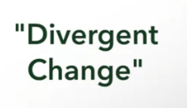

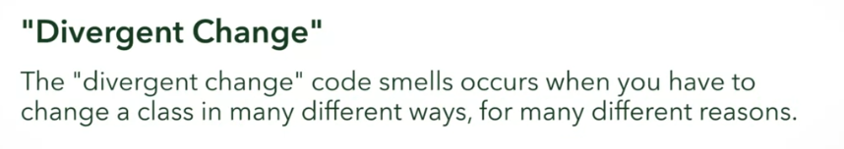

Relates to **“Large Class”**

Solution:



SECOND CODE SMELL



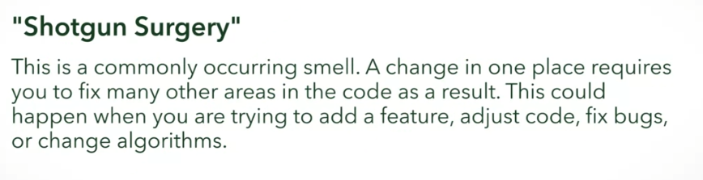

Solution:

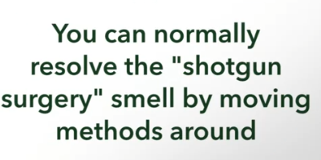

THIRD CODE SMELL



* One method is interested in the details of another class other than the one that is in
* Two methods/classes are always talking to each other and seems like they need to be together, chances are they probably SHOULD

FOURTH CODE SMELL

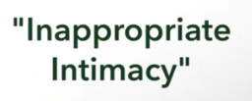

* Two classes depend on each other way too much on two-way communication
* 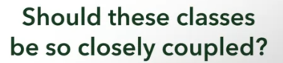
  + Probably not
* Solution: introduce a new class (like a mediator)

FIFTH CODE SMELL





* Potentially violates Law of Demeter

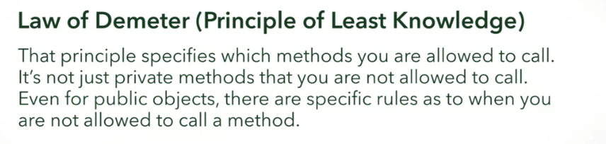

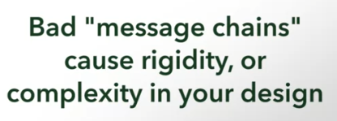

SIXTH CODE SMELL



* Rely too much in these
  + Int
  + String
  + Boolean
* 

Example:

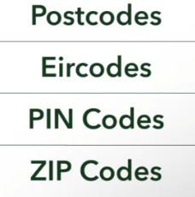 

* We USUALLY store this as string BUT that is what we must AVOID

Solution:



SEVENTH CODE SMELL



Example of Switch Code Smell:

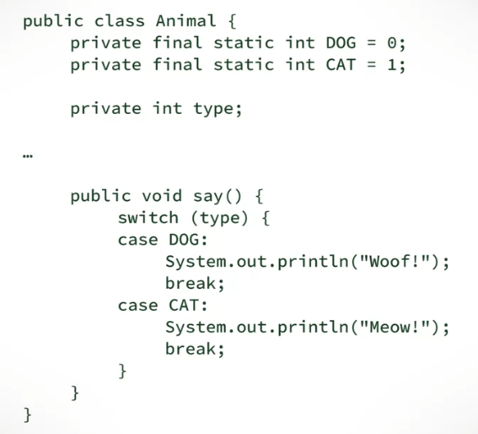

Solution of Switch Code Smell:

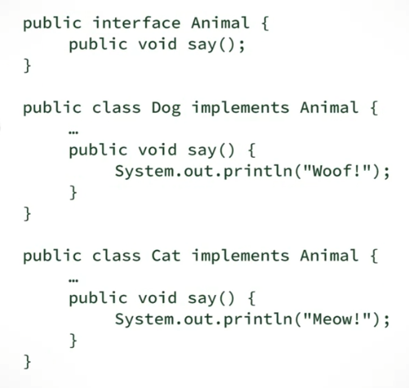

EIGHTH CODE SMELL



* “WE MIGHT NEED IT SOMEDAY”

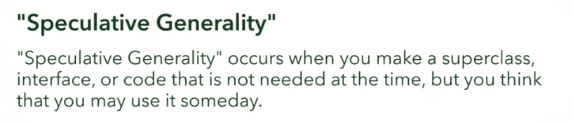



IN:





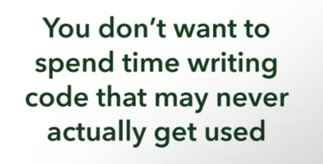

NINTH CODE SMELL

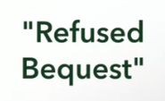

* When a subclass inherits something and DOES NOT NEED IT

